Project Design Phase
Date | 11 September 2026
Project Name | Employee Raise Issue
Maximum Marks | 2 Marks
Proposed Solution Template:
Proposed Solution Template:
S.No. | Parameter | Description
 | Problem Statement (Problem to be solved) | Employees need a simple and centralized way to report workplace or IT-related issues. The existing process can be confusing, may require incomplete information, and can make it difficult to track submitted issues.
 | Idea / Solution description | Develop an Employee Raise Issue application in ServiceNow. Employees can access the Employee Center/Service Portal, open the Raise Employee Issue Record Producer, enter the required details, select Category and dependent Subcategory, and submit the issue. The submitted information is stored in the Employee Raise Issue table for administrative management.
 | Novelty / Uniqueness | The solution combines a guided Record Producer, mandatory fields, Category–Subcategory dependency, UI Policies and Client Scripts to create a structured and user-friendly issue-reporting process. The centralized ServiceNow approach reduces manual handling and improves consistency.
 | Social Impact / Customer Satisfaction | The application provides employees with an easier and more organized way to communicate workplace issues. It reduces confusion during submission, improves the quality of issue information, and helps support users manage employee concerns more efficiently.
 | Business Model (Revenue Model) | This is primarily an internal organizational solution rather than a direct revenue-generating product. Its value comes from reducing manual effort, improving support-process efficiency, and providing centralized issue management.
 | Scalability of the Solution | The solution can be extended by adding automated notifications, approval workflows, SLA tracking, reports, dashboards, additional issue categories, and integrations with other organizational systems.

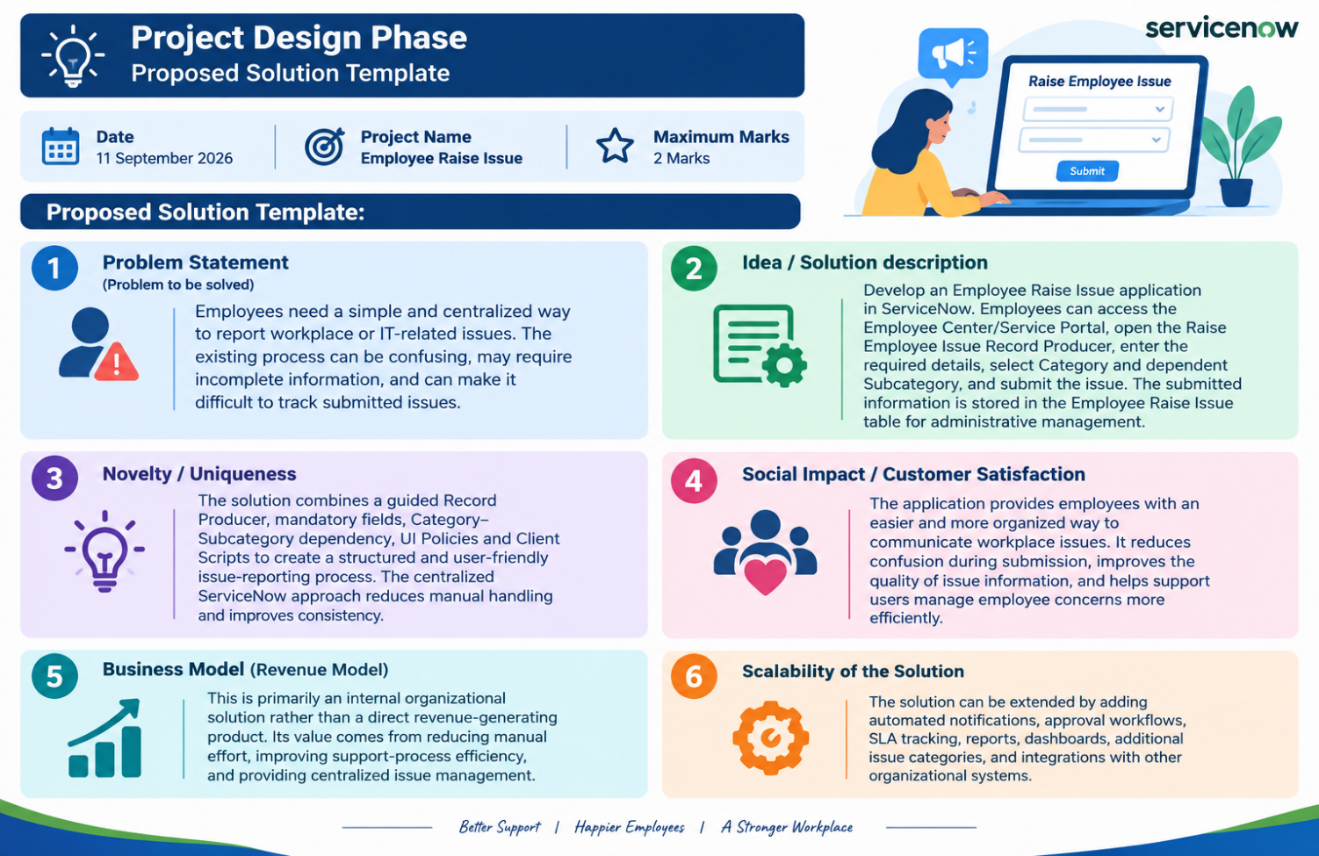

Proposed Solution:
The proposed solution is a ServiceNow-based Employee Raise Issue Management System designed to provide employees with a centralized platform for reporting workplace and IT-related issues. The system simplifies issue submission while providing administrators with structured records for effective management and tracking.

